TESTING AND IMPROVING
YOUR SOLAR PANEL

In this activity, you will be given a small solar panel to test and improve. Your goal is to figure out how much electricity is produced by the panel by itself, and then how much electricity can be produced by making some improvements to the solar panel. First you will put a magnifying glass over it, then you will surround it with different colors of paper, and lastly you will surround the panel with a set of mirrors. As more of the light is directed onto the solar panel, it will produce more electricity! Your last goal is to use any of the materials you have been given to try and reach the highest electricity output possible, measured in millivolts (thousandths of a volt).

RULES:
- Don’t move or touch the lights
- Don’t interfere with other groups – work only with your group
- Share the materials and the lights with everyone

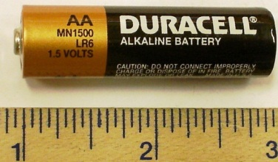
If your solar panel output says 500 millivolts,
this is equal to .5 volts!
This AA battery has 1.5 volts.

INSTRUCTIONS:
- Assemble your House + Solar Panel
- Test the solar panel, and Record the millivolts produced
- Test the solar panel with the Magnifying Glass
- Test the solar panel with the White paper surrounding it
- Test the solar panel with the Blue paper surrounding it
- Test the solar panel with the Yellow paper surrounding it
- Test the solar panel with the Red paper surrounding it
- Test the solar panel with the Aluminum Foil surrounding it
- Test the solar panel using ANY of the materials you have to try and get the highest output of electricity that you can
DATA RECORDING:
All of your results will be in millivolts – you can write 500 mV as the abbreviation.

1. Output from the Solar Panel: ___________________
2. Output from the Magnifying Glass: ___________________
3. Output from the White paper: ___________________
4. Output from the Blue paper: ___________________
5. Output from the Yellow paper: ___________________
6. Output from the Red paper: ___________________
7. Output from the Aluminum Foil: ___________________
8. Your Highest Output using any combo: ___________________
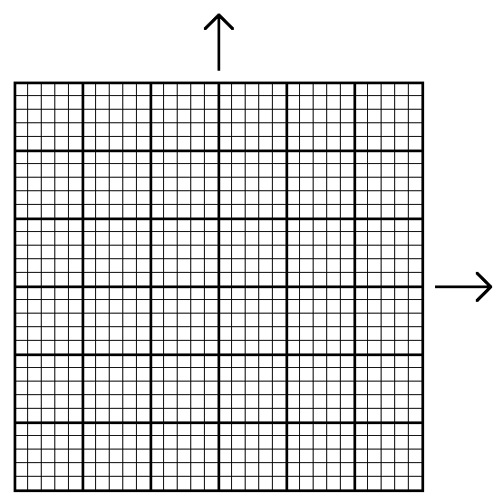
1. Solar Panel Alone
2. Magnifying
Glass
3. White Paper
4. Blue
Paper
5. Yellow Paper
6. Red Paper
7. Aluminum Foil
8. Best Combination
400 mV
500 mV
600 mV
700 mV
800 mV
900 mV
1000 mV

