HIGH POWERED PAPER ROCKETS

# Rocket Construction Guidelines

Independently, you will create a paper rocket with a nosecone, cardboard fins, and one of the following materials for the fuselage (body) of the rocket:

* Notecard
* Piece of paper
* 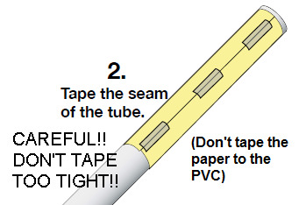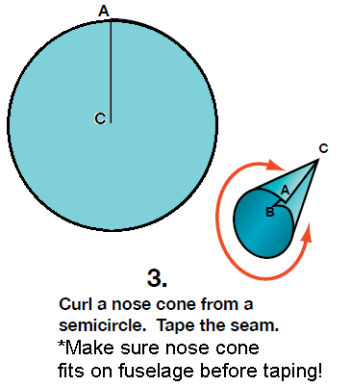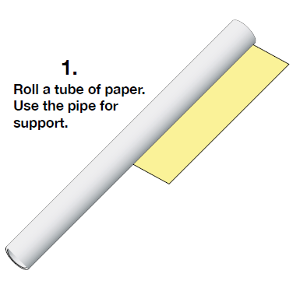Piece of cardboard paper

  
  
  
  
  
  
  
  
  
  
  
  
  
  
  
  
  
  
  
  
  
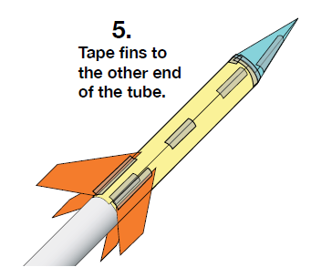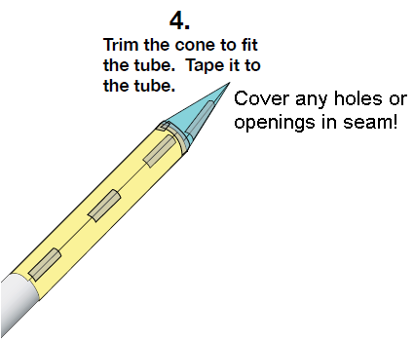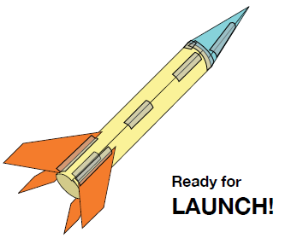You must also decide on the shape and number of fins you will be using! Anywhere from 3 – 5 is optimal. Use one of the two methods shown below, or devise your own way of attaching fins!

**Note: you can make your rocket body as small or as large as you want.**

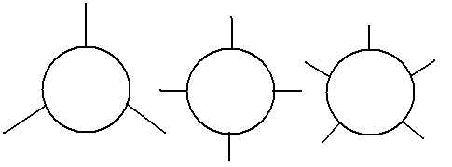

**DATA COLLECTION - PAPER ROCKETS**

**Data to Record:**

Mass of Rocket (grams): _____________

Length of Body (centimeters): _____________

Number of Fins: _____________

Total Time of Flight (seconds): _____________

**Calculations:**

Maximum Height (meters) = (1/2) * (gravity) * (time/2)2 = ______________________

Gravity = 9.8 meters/seconds2(or 32 feet/second2)

**Analysis:**

1. How does the mass of the rocket affect its performance?

2. How does the length of the rocket affect its performance?

3. What other factors impact the performance of the rocket?

4. Using what you’ve observed, what would the “ideal” rocket look like?

**DATA COLLECTION - PAPER ROCKETS**

**Data to Record:**

Mass of Rocket (grams): _____________

Length of Body (centimeters): _____________

Number of Fins: _____________

Total Time of Flight (seconds): _____________

**Calculations:**

Maximum Height (meters) = (1/2) * (gravity) * (time/2)2 = ______________________

Gravity = 9.8 meters/seconds2(or 32 feet/second2)

**Analysis:**

1. How does the mass of the rocket affect its performance?

2. How does the length of the rocket affect its performance?

3. What other factors impact the performance of the rocket?

4. Using what you’ve observed, what would the “ideal” rocket look like?

|  |  |  |  |
| --- | --- | --- | --- |
| **Group Name** | **Time of flight (sec)** | **Group Name** | **Time of flight (sec)** |
|  |  |  |  |
|  |  |  |  |
|  |  |  |  |
|  |  |  |  |
|  |  |  |  |
|  |  |  |  |
|  |  |  |  |
|  |  |  |  |
|  |  |  |  |
|  |  |  |  |
|  |  |  |  |
|  |  |  |  |
|  |  |  |  |
|  |  |  |  |