2019 BPS Science and Engineering Fair
Activity Expo – Table Assignments
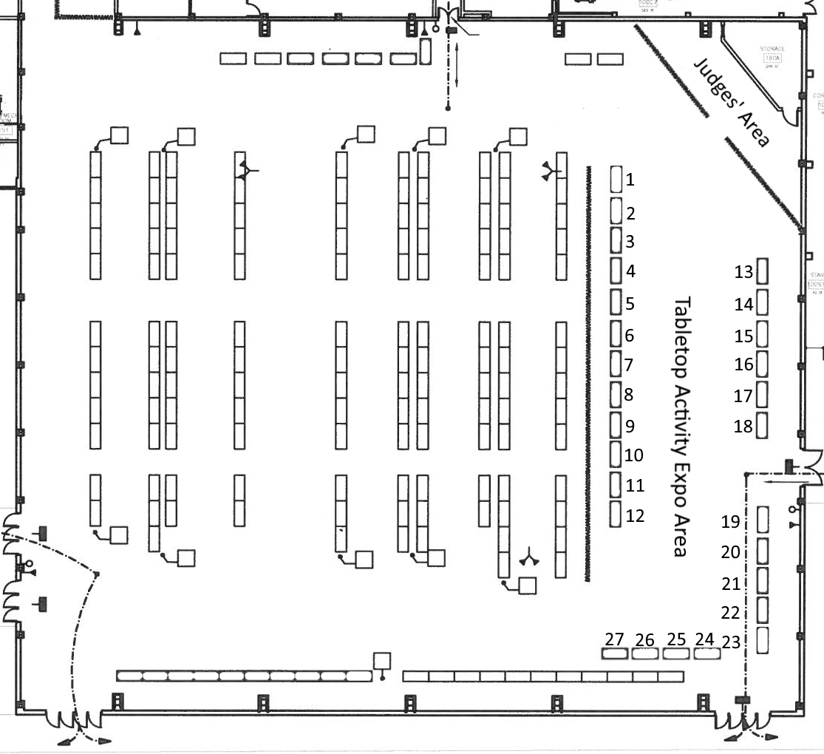
Activity Expo Schedule:
10:00am - 12:00pm [Private, attendance for Fair Exhibitors/Judges only]
12:00pm - 1:25pm [Lunch, exhibition room will be locked and no entry during this time]
1:30pm - 3:00pm [Public, attendance for Everyone]
Table # | Group/Organization |  | Activity Title
1 | Metropolitan Waterworks Museum |  | The "Work" in Waterworks
2 | Beyond Benign | Sharklet Technology: Secrets of Shark Skin
3 | AIChE - Northeastern Chapter |  | Raining Blood
4 | First Byte |  | MaKey MaKey Showcase
5
6 | Wireless Club |  | Arduino Circuits
7 | IEEE - Northeaster Chapter |  | Snap Circuits & Squishy Circuits
8
9 | NU Sustainable Building Organization |  | Green Roof Demonstration
10 | STEMout |  | Paper Towers
11 | Toysinbox 3D Printing |  | Fun with 3D Printing
12
13 | Civil Air Patrol, Boston Squadron |  | Flight Simulator
14 | Harvard Museum of Natural History |  | Natural History Exhibits
15 | NU Marine Science Center |  | Marine Touch Tanks
16
17 | Another Course to College |  | Pepper Robots &  MakerSpace Projects
18
19 | Cambridge Science Festival |  | Wind Table &  Mystery Tubes
20
21 | Engineers Without Borders |  | Bridge Building
22 | Journal of Emerging Investigators |  | Publish in a Journal
23 | Extra Table Space (not in use)
24 | iRobot |  | iRobot Robotics Demos
25
26 | Mass Maritime Academy |  | Morse Code Translator
27 | Build Your Own Walkalong Gliders |  | Walkalong Glider Flight School

