Morse Code
Developed in the 1830s and 1840s by Samuel Morse (1791-1872) and other inventors, the telegraph revolutionized long-distance communication. It worked by transmitting electrical signals over a wire laid between stations. In addition to helping invent the telegraph, Samuel Morse developed a code (bearing his name) that assigned a set of dots and dashes to each letter of the English alphabet and allowed for the simple transmission of complex messages across telegraph lines. In 1844, Morse sent his first telegraph message, from Washington, D.C., to Baltimore, Maryland. By 1866, a telegraph line had been laid across the Atlantic Ocean from the U.S. to Europe.
Morse code is usually transmitted by on-off keying (switching on and off) of an information-carrying medium, such as electric current, radio waves, visible light or sound waves. Each Morse code symbol is formed by a sequence of dots and dashes. To increase the efficiency of encoding, Morse code was designed so that the length of each symbol is approximately inverse to the frequency of occurrence in text of the English language character that it represents. Thus the most common letter in English, the letter "E", has the shortest code: a single dot. Punctuation (such as . or ?) exists in Morse code, but there is no distinction between upper and lower case letters. Additionally, because many non-English languages use letters other than the 26 Roman letters (a, b, c, etc.), Morse alphabets have been developed for those languages (Ł, Ö, þ, Ѫ, etc.).
When transmitting Morse code, each symbol represents how long to leave the circuit on for: how long the sound plays for or how long the light is on, etc. A dot is one “unit” of time, whilst a dash is three times as long, 3 units. When signaling a different symbol (as part of the same letter), or indicating a new letter or word, the circuit is turned off (such as the sound stopping or the light turning off). This pause also has a specific length: to indicate another symbol in the same letter, you pause one “unit” of time, to indicate a new letter you pause 3 units of time, and a new word is 7 units of time.
Because the Morse code elements are specified by units of time rather than specific time durations, the code is usually transmitted at the highest rate that the receiver is capable of decoding. For example, if sending a transmission using a flashlight, a dot might be 1 second and a dash 3 seconds, whilst using a signal fire a dot might be 10 minutes whilst a dash is thirty minutes.
In an emergency, Morse code can be generated by improvised methods such as turning a light on and off, tapping on an object or sounding a horn or whistle, making it one of the simplest and most versatile methods of telecommunication. The most common distress signal is SOS – three dots, three dashes, and three dots – internationally recognized by treaty.
SOS, the internationally recognized distress signal, does not stand for any particular words. Instead, the letters were chosen because they are easy to transmit in Morse code: "S" is three dots, and "O" is three dashes.
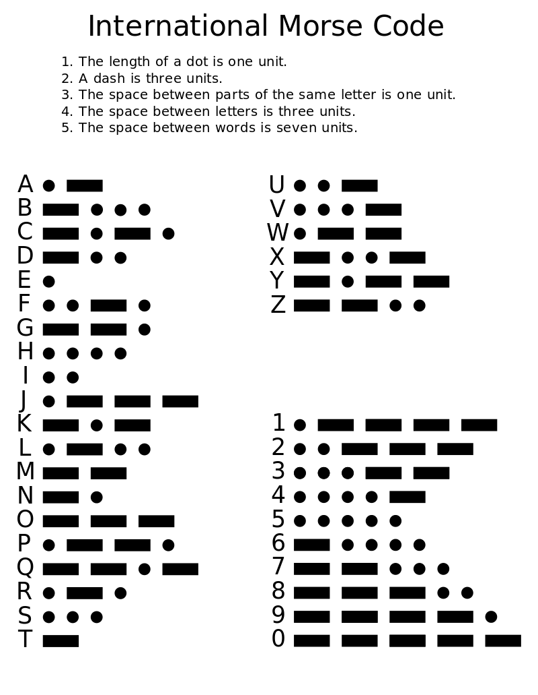

Let’s try it out!
1. Build a circuit using the Snap Circuits kits. You may either build a circuit using a light or a sound, but either way, your circuit needs a switch so that you can easily turn the circuit on and off (i.e. closed and open).
2. Determine your “unit” of time, i.e. how quickly your partner can receive your message. Remember that a dot is 1 unit of time and a dash is 3 units of time. Half a second or a second is reasonable as 1 unit.
3. Come up with three messages you want to send. I would suggest starting with a one word message first, such as a word or a number (such as having your partners guess your favorite number or your age). The second message could be a longer word or number, whilst the third message should be a full sentence.
4. Send and receive your messages. Use the back if you want to send/receive more
Messages to Send:
Message 1: _______________________________________ Received Correctly?
Code to send:
Message 2: _______________________________________ Received Correctly?
Code to send:
Message 3: _______________________________________ Received Correctly?
Code to send:
Messages Received:
Code 1 Received:
Message Meaning: __________________________________________________
Code 2 Received:
Message Meaning: __________________________________________________
Code 3 Received:
Message Meaning: __________________________________________________

