CATAPULTS

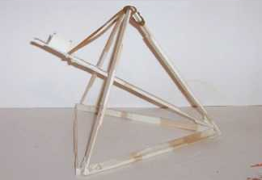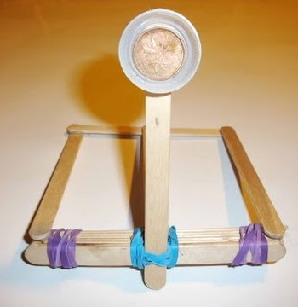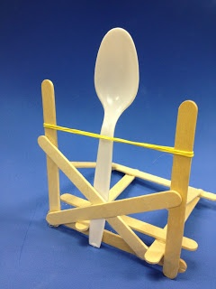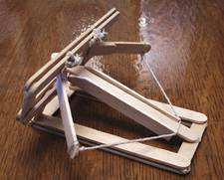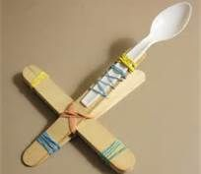
Challenge
Working with a partner, you will build a catapult in whatever way you choose. You will create your own design using Popsicle sticks, tape, rubber bands, and plastic spoons. You should aim to make your catapult sturdy and repeatable - one shot will not get the job done. Your goal is to gather the most possible points during launch tests.
Before you get any materials to build, you need to sketch a blueprint of your design:

Testing - Round 1:  Points for Shot 1: ______  Points for Shot 2: ______  Points for Shot 3: ______  Total Points: ______  Observations:  How can you improve your catapult? | Testing - Round 2:  Points for Shot 1: ______  Points for Shot 2: ______  Points for Shot 3: ______  Total Points: ______  Observations:  How can you improve your catapult?

Conclusions
Compare your catapult to others. What makes for a good catapult?
Define the engineering design process and the steps involved. What is the engineering design process used for?
1.
2.
3.
4.
5.
What is the importance of the angle at which you launch an object? What is the ideal angle to launch from?
What is the difference between accuracy and precision?

