Team Member Names: Date: _____________________________________________________ ___________

Protecting Our City with Deployable Levees
Design Worksheet
Instructions
Follow the design process in this worksheet to design, build and test your model levee.
STEP 1: Define the problem. In this step, you determine what the problem is that you need to solve, and what your design constraints are. These are often given to you.
- Problem: Build a new levee system that will maintain the boundary between the water and the people.
- Constraints:
  - Size: A real levee must be higher than sea level and wide enough to prevent water going around it: Your prototype must be at least as high as half the tub, and wide enough to prevent the water on one side of a plastic container from flooding into the other side of the container.
  - Rapid Deployment: The levee must be able to be put in place in 30 seconds and cannot be permanent: it must be able to be removed in 30 seconds or less.
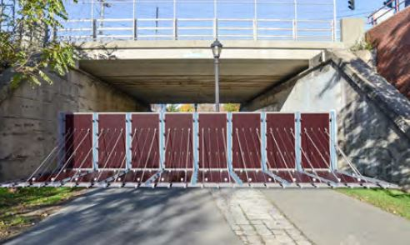
  - Budget & Materials: Each group receives a plastic container in which to design their prototype levee. Each team receives $10 to purchase levee supplies. You may only buy from the list of approved materials (see Bill of Materials). Purchased materials cannot be returned. You may however buy additional materials after purchasing materials the first time, assuming you have enough money left over.
STEP 2: Brainstorm ideas. When engineers brainstorm ideas, they are open to as many creative ideas as possible. No idea or suggestion is “silly”; in fact, the wilder the idea, the better!
Discuss ideas for how to build your levee. In the space below, write down and/or sketch every idea suggested.

STEP 3: Select the most promising concept. Read through your ideas again, and choose the concept that you think will work best.
Describe and/or sketch your idea in the space below. Make sure to label your design.

Use the following table (called a Bill of Materials) to determine how you will spend your budget on materials.
Material | Cost  in “$” | Amount You Want | Cost
1 cup of sand (limit: 2) | 1
1 cup of gravel (limit: 2) | 1
5 cotton balls | 1
3 straws | 1
3 popsicle sticks | 1
1 foot duct tape | 2
1 sheet of cardboard | 2
1 plastic sheet | 2
1 half sheet of foam | 2
1 half sheet of cloth felt | 2
TOTAL
STEP 4: Build and test. Purchase materials and build your levee prototype. Remember to not build your levee into the container - when you are ready to test, you will be given the container again and timed how long the levee took to deploy, how long the levee survived, and how long it took to remove the levee.
STEP 5: Evaluate your design. After engineers test their prototypes, they think about how well it worked. This helps them make changes to improve the final, real version.

