Team Member Names: ________________________________________ Date: _________
PORTABLE FLOTATION DEVICE CHALLENGE
(Time: 60 minutes)
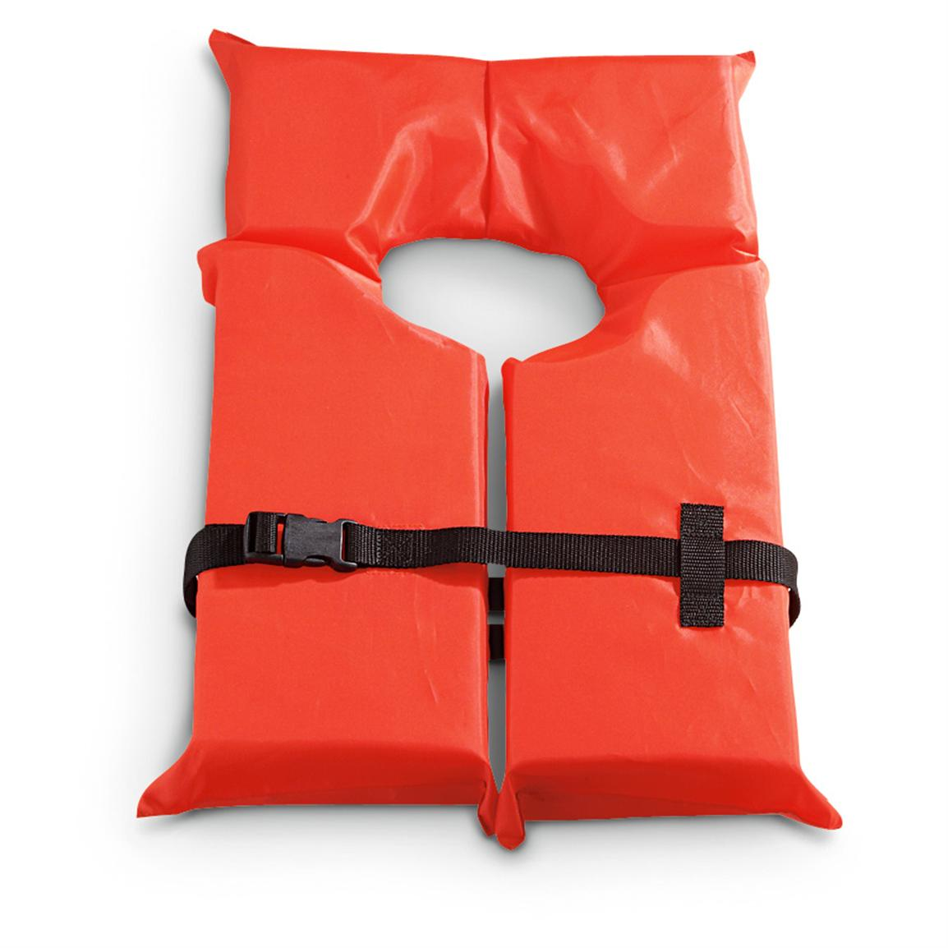

Background: In 2017, Hurricane Harvey slammed into Texas, causing drastic flooding in many areas; some areas received over 40 inches of rain! People affected by storms like this are often put in grave danger because they do not know how or are too injured to swim in the flood waters. Situations like this is when effective personal flotation devices are vital and can save lives.

Objective: In teams, you will explore this concept on a smaller scale, and design and create a personal flotation device (PFD) that can keep a can of soup (representing a person) afloat for as long as possible and can be attached as quickly as possible. You also must try to keep your design as inexpensive as possible.

Constraints:
- Device must be created using only the materials provided
- Device must allow part of the can to be in contact with the water

Procedure:
- Consider your materials and their cost and begin brainstorming ideas for your design
- With your team, narrow in on a single idea and begin sketching it in the space provided
- Use your materials to create an initial prototype of your design
- Test how quickly it can be attached to Can
- Test your device in a small tub of water
- Document the results and the faults in your design
- Redesign and improve your design for final testing
- Participate in the final testing!

Materials:
Use this space to plan out your materials:
MATERIAL | COST
1 Cork | $5
1 Foam Block | $8
1 Rubber Band | $10
1 Length of String | $6
1 Piece of Duct Tape | $8
1 Sandwich Bag | $12

Brainstorming/Designing

Testing: Your device will be put to the test and scored based on three aspects: how long it stays afloat, how quickly it can be attached to the can, and how much it costs.

(NOTE: If a team’s PFD stays afloat for 5 minutes or more, “time afloat” score will max out at 300 seconds)

Cost of your PFD:
MATERIAL | QTY | PRICE | QTY*PRICE
1 Cork |  | $5
1 Foam Block |  | $8
1 Rubber Band |  | $10
1 Length of String |  | $6
1 Piece of Duct Tape |  | $8
1 Sandwich Bag |  | $12
TOTAL COST | ------ | ------> | $________
Time PFD stayed afloat: _________
Points for time taken to attach PFD:
Time to affix device (In Seconds) | Points
0 - 5 | +500
5 - 10 | +400
10 - 15 | +300
15 - 20 | +200
>20 | +100

Score:
800 - Time Afloat (in seconds) - Affixing Points + 2*Cost

800 - _________ - _________ + 2*_________ = __________
Time afloat Affixing Points Cost FINAL SCORE

Follow-up Questions:

Did your device perform as well as you expected? Why or why not?
_______________________________________________________________________________________________________________________________________________________________________________________________________________
If you could go back in time and do something differently in the design process, what would you change and why?
_______________________________________________________________________________________________________________________________________________________________________________________________________________
_____________________________________________________________________
How did working in a team help improve the design process and your design? If it did not help, what could your team have done differently to change this?
_____________________________________________________________________
_____________________________________________________________________
_____________________________________________________________________

