Kitchen Layout Activity
Team Members:_____________________________________________________________
Kit includes:
- 1 page of .5” graph paper with 2” long door marked at center of short edge
- Oven 2”x2”
- Fridge 2”x2”
- Sink 2”x2”
- Tabletop 1 2”x2”
- Tabletop 2 2”x2”
- Cabinet 2”x2”
- Place marker (For counting spaces)
Background:
University at Buffalo Industrial Engineering Video https://www.youtube.com/watch?v=WMbJuTlajsw
What’s an Industrial Engineer?
Industrial Engineers work every day to make systems work better, faster, and for less money. They can work in many different fields including hospitals to make sure patients receive the care they need as efficiently as possible, amusement parks like Disney World where they improve wait times to get onto rides and where they make the wait more fun, and manufacturing environments including candy manufacturing where they can work on anything from making sure every piece of candy is as good as it can be to changing how a factory is laid out to help make their products faster.

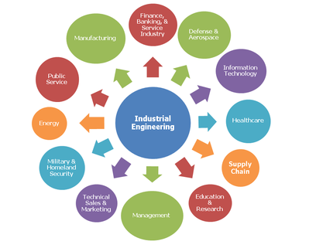
Part 1 – Designing Your Kitchen Layout
Objective:
The objective of this activity is to figure out how you would lay out a kitchen in order to make cookies with as few steps as possible given the graph paper and kitchen features provided. You must go to the bolded features listed in the steps below in the order in which they are listed. To “go to” a feature, you must move your place marker next to one of its dark borders.
Steps:

- Enter the Kitchen Door
- Preheat the Oven
- Get ingredients from the Fridge
- Bring ingredients to Tabletop 1
- Get ingredients from the Cabinet
- Bring ingredients to Tabletop 1
~Mix batter!~
- Bring cookie batter to Tabletop 2
~Put Cookies on the tray!~
- Bring tray of cookies to the Oven to bake
- Go to Tabletop 2 to pick up the dirty mixing bowl
- Bring the dirty mixing bowl to the Sink
~Wash the dishes~
- Go to Tabletop 1 to pick up the refrigerated ingredients
- Bring the ingredients to the Fridge
- Go to Tabletop 1 to pick up the dry ingredients
- Bring the ingredients to the Cabinet
- Go to the Oven to take out the cookies
- Bring the cookies to cool on Tabletop 1

Restrictions (constraints):
- You must place the kitchen figures so that their dark borders are at least two spaces away from any other kitchen feature, wall, or doorway.

Before we start guessing what may be the most efficient layout, let’s break down the problem:
We can start by making an Activity Relationship Diagram which is a tool Industrial Engineers use to visually represent the importance of relationships between the different components of a given layout
Go through the steps above and, starting with the kitchen door and step 1, every time you see a feature in bold, draw a line from your current feature to the feature named.
Example: Step 2 is to “Preheat the Oven” so you would draw a line from the Kitchen door to the oven.
 | Importance
0 | Not Important
1 | Somewhat Important
2 | Important
3 | Very Important

How many lines are there between each of the following pairs of features?
 | Feature Pairs | Number of lines
1 | Kitchen Door – Oven
2 | Oven – Cabinet
3 | Oven – Fridge
4 | Oven – Tabletop 1
5 | Oven – Tabletop 2
6 | Fridge – Tabletop 1
7 | Sink – Tabletop 1
8 | Sink – Tabletop 2
9 | Tabletop 1 – Tabletop 2
10 | Tabletop 1 – Cabinet

Rank the pairs from the most lines to the fewest by writing the letter for each pair in the “New Order” column (if there are multiple pairs with the same number of lines, the order between them doesn’t matter).
 | Old Order |  |  | New Order
A | Kitchen Door – Oven |  | 1
B | Oven – Cabinet |  | 2
C | Oven – Fridge |  | 3
D | Oven – Tabletop 1 |  | 4
E | Oven – Tabletop 2 |  | 5
F | Fridge – Tabletop 1 |  | 6
G | Sink – Tabletop 1 |  | 7
H | Sink – Tabletop 2 |  | 8
I | Tabletop 1 – Tabletop 2 |  | 9
J | Tabletop 1 – Cabinet |  | 10

Based on this ranking, which features should be closest together? Why?

Work with your partner(s) to create your kitchen layout using the graph paper and feature squares. When you think you have a good layout, use the table below to record the number of spaces you move for each step
# | Steps | # of spaces moved
1 | Enter the Kitchen Door
2 | Preheat the Oven
3 | Get ingredients from the Fridge
4 | Bring ingredients to Tabletop 1
5 | Get ingredients from the Cabinet
6 | Bring ingredients to Tabletop 1
7 | Bring cookie batter to Tabletop 2
8 | Bring tray of cookies to the Oven to bake
9 | Go to Tabletop 2 to pick up the dirty mixing bowl
10 | Bring the dirty mixing bowl to the Sink
11 | Go to Tabletop 1 to pick up the refrigerated ingredients
12 | Bring the ingredients to the Fridge
13 | Go to Tabletop 1 to pick up the dry ingredients
14 | Bring the ingredients to the Cabinet
15 | Go to the Oven to take out the cookies
16 | Bring the cookies to cool on Tabletop 1
 | Total:

When you’ve finished recording your movements, have a volunteer come check your layout.
Part 2 – Reordering Cookie Making Steps
Unfortunately, in real life we can’t rearrange our kitchens every time we make a new recipe. In this case, we have to rearrange the steps to perform optimally within a given layout.
Objective: Given the new kitchen layout provided on the next page, reorder the steps below in order to complete all of the tasks while moving the fewest spaces.
NOTE: The steps have changed slightly from above, please read through them carefully.
Steps:
Obtain a baseline by counting the number of spaces moved between the steps in their original order.
NOTE: You may put 0 steps when appropriate
 | Original Order for the Steps | # of spaces moved
A | Enter the Kitchen Door | 0
B | Preheat the Oven
C | Get refrigerated ingredients from the Fridge
D | Bring refrigerated ingredients to Tabletop 1
E | Get dry ingredients from the Cabinet
F | Bring dry ingredients to Tabletop 1
G | Mix refrigerated and dry ingredients to make batter at Tabletop 1
H | Pick up the refrigerated ingredients from Tabletop 1
I | Bring refrigerated ingredients back to the Fridge
J | Pick up dry ingredients from Tabletop 1
K | Bring dry ingredients back to the Cabinet
L | Pick up cookie batter from Tabletop 1
M | Bring cookie batter to Tabletop 2
N | Form cookie batter into cookies on the tray at Tabletop 2
O | Pick up prepared cookie tray from Tabletop 2
P | Bring tray of cookies to the Oven to bake
Q | Pick up the dirty mixing bowl from Tabletop 2
R | Bring the dirty mixing bowl to the Sink
S | Wash the dishes in the Sink
T | Go to the Oven to take out the cookies
U | Bring the cookies to cool on Tabletop 1
 | Total:

Restrictions (Constraints): In any process, there are going to be some steps that must come before others can be completed, and sometimes multiple steps may even be needed.
When you are reordering your steps, please make sure that the order still makes sense. For instance, you have to preheat the oven before you can bake in it and you have to mix the batter before you can make cookies. In every case, however, you must begin with “Enter the Kitchen Door.”
You can also assume that you can carry multiple kinds of items at once.
The rules regarding your place marker from the previous part still apply.
 |  |  | 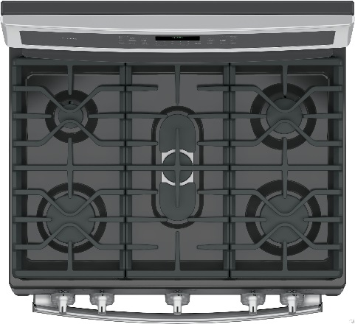  Oven |  |  |  |  | 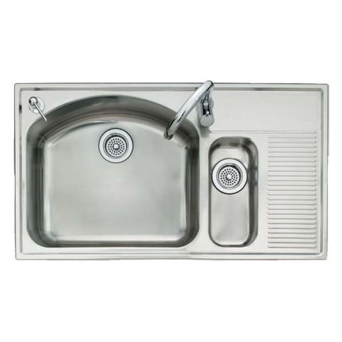  Sink
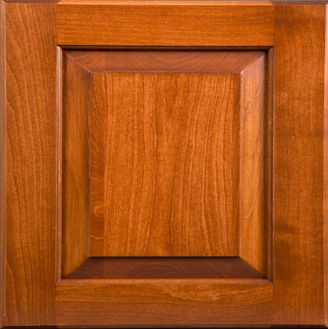
Cabinet
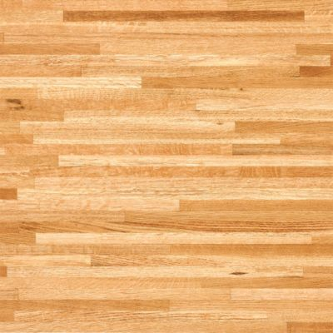
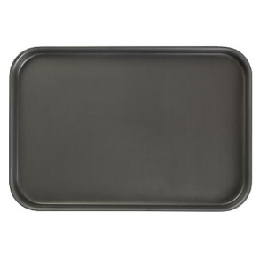
Tabletop 2

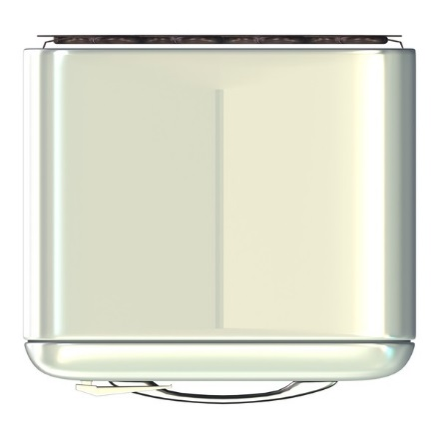
Fridge

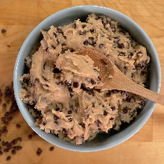
Tabletop 1

 |  |  |  |  |  | Door
In developing your own order for the step, think about the following questions:
- Which features are closest together?
- Are there any existing steps between those features?
- In steps where there is a larger distance to travel, is there a way to make the trip Value Adding? (A value adding event is an event that increases the value of a process, in this case finding additional steps that you can make on the way to completing another step would be value adding.)
- Think about the Activity Relationship Diagram, from the previous part of this activity. How can you use the information gained from that exercise for this part? You can develop your own diagram on the back of this page if you’d like.

 | Original Order for the Steps | New Order | # of spaces moved
A | Enter the Kitchen Door | A
B | Preheat the Oven
C | Get refrigerated ingredients from the Fridge
D | Bring refrigerated ingredients to Tabletop 1
E | Get dry ingredients from the Cabinet
F | Bring dry ingredients to Tabletop 1
G | Mix refrigerated and dry ingredients to make batter at Tabletop 1
H | Pick up the refrigerated ingredients from Tabletop 1
I | Bring refrigerated ingredients back to the Fridge
J | Pick up dry ingredients from Tabletop 1
K | Bring dry ingredients back to the Cabinet
L | Pick up cookie batter from Tabletop 1
M | Bring cookie batter to Tabletop 2
N | Form cookie batter into cookies on the tray at Tabletop 2
O | Pick up prepared cookie tray from Tabletop 2
P | Bring tray of cookies to the Oven to bake
Q | Pick up the dirty mixing bowl from Tabletop 2
R | Bring the dirty mixing bowl to the Sink
S | Wash the dishes in the Sink
T | Go to the Oven to take out the cookies
U | Bring the cookies to cool on Tabletop 1
 |  | Total:

