Manufacturing Efficiency: Industrial Engineering
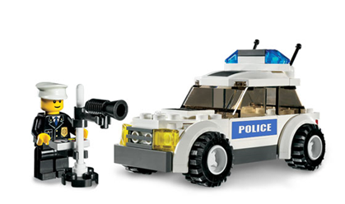
Materials Needed:
- Lego Car Parts
- One stopwatch
- Instructions for either individual cars or car subassemblies
Instructions:
- You will receive a large Ziploc bag containing the parts to assemble 10 Lego Cars.
- Assign one person to be the timer and make sure they know how to use a stopwatch.
- Your group will be assigned one of two styles of assembly, craft or factory
  - Craft Style:
    - You will receive a bag with 10 bags, one for each car.
    - You must assemble them one car at a time.
    - Allocate your resources as you want.
    - Your goal is to complete your ten cars as quickly as possible.
  - Factory Style:
    - You will receive a bag with 5 bags inside, each bag contains parts for 10 subassemblies.
    - You must assemble your cars using these subassemblies, which are then combined to make 10 cars.
    - Set up an assembly line in some way, you may move workers as you need to. You have instructions for each subassembly in the bag.
    - Your goal is to complete them as quickly as possible.
- All Team Members must participate, so everyone must have a meaningful job in this process.
- Cars must be constructed correctly and will be inspected. They must be reworked if assembled incorrectly. Lego instructions are available if any part is unclear.
- Do not be afraid to shift assemblers, or help each other, teamwork is crucial. More experienced assemblers should train and help those with less expertise.

Note: You are just assembling cars, not the man or the radar gun.

Assessment
- Which style have you been assigned?
Craft Factory
- Who will do the timekeeping for your group?:
- Your group must now build 10 cars.
- Stop the clock when you think you are all finished and call a Quality Control Inspector over to check your work.
- If there are any errors you must start the clock again and add that time to your table below.
- Record your times here:
Time to complete 10 cars | Additional time  ( to fix errors ) | Additional time  ( to fix errors ) | Total time
- When the Quality Control Engineers are satisfied they will place your final time on the board. Now it is time to think like an Industrial Engineer!
- Examine the board. Which style seemed to be the best for this project ? Why?
- Can you think of anything that could be done to improve the process?

