What Is This Thing?
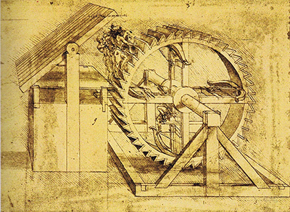
Background: Engineers have been constructing strange machines and apparatuses for all of human history. Some machines may look strange, but everything that is built has a purpose!
Instructions: Look carefully through each of the following images. Your job is to make your best hypothesis as to:
- What is each machine called?
- What does each machine do? / What problem does it solve?
- What about the machine led you to make these conclusions?
Record your answers in the table below!

IMG | What is it called? | What is it for / What problem does it solve? | How do you know?
1
2
3
4
5
6
7
8
9
10
11
12
13
14
15
16
17
18
IMG | What is it called? | What is it for / What problem does it solve? | How do you know?
19
20
21
22
23
24
25
26
27
28
29
30
31
32
33

